2/18/2022

3152/B Hardik Togadiya

PHP

Assignment-2

1. Write JavaScript code for print Hello Computer message using alert box.

<html>

  <body>

    <button onClick="myFunction()"> Click Me </button>

    <script>

      function myFunction(){

        alert("Hello World!");

    }

    </script>

  </body>

</html>

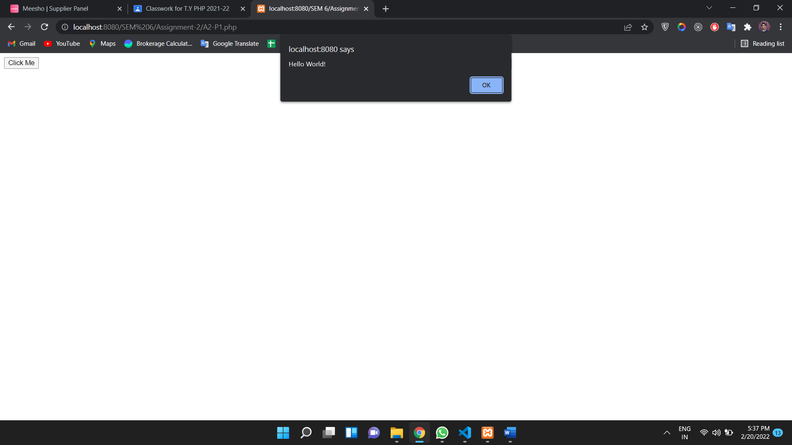

2. Write a JavaScript code for Client side validation.

<!DOCTYPE html>

<html>

<head>

<style>

.error {color: #FF0001;}

</style>

</head>

<body>

<?php

// define variables to empty values

$nameErr = $emailErr = $mobilenoErr = $genderErr = $websiteErr = $agreeErr = "";

$name = $email = $mobileno = $gender = $website = $agree = "";

//Input fields validation

if ($_SERVER["REQUEST_METHOD"] == "POST") {

//String Validation

    if (empty($_POST["name"])) {

         $nameErr = "Name is required";

    } else {

        $name = input_data($_POST["name"]);

            // check if name only contains letters and whitespace

            if (!preg_match("/^[a-zA-Z ]*$/",$name)) {

                $nameErr = "Only alphabets and white space are allowed";

            }

    }

    //Email Validation

    if (empty($_POST["email"])) {

            $emailErr = "Email is required";

    } else {

            $email = input_data($_POST["email"]);

            // check that the e-mail address is well-formed

            if (!filter_var($email, FILTER_VALIDATE_EMAIL)) {

                $emailErr = "Invalid email format";

            }

     }

    //Number Validation

    if (empty($_POST["mobileno"])) {

            $mobilenoErr = "Mobile no is required";

    } else {

            $mobileno = input_data($_POST["mobileno"]);

            // check if mobile no is well-formed

            if (!preg_match ("/^[0-9]*$/", $mobileno) ) {

            $mobilenoErr = "Only numeric value is allowed.";

            }

        //check mobile no length should not be less and greator than 10

        if (strlen ($mobileno) != 10) {

            $mobilenoErr = "Mobile no must contain 10 digits.";

            }

    }

    //URL Validation

    if (empty($_POST["website"])) {

        $website = "";

    } else {

            $website = input_data($_POST["website"]);

            // check if URL address syntax is valid

            if (!preg_match("/\b(?:(?:https?|ftp):\/\/|www\.)[-a-z0-9+&@#\/%?=~_|!:,.;]*[-a-z0-9+&@#\/%=~_|]/i",$website)) {

                $websiteErr = "Invalid URL";

            }

    }

    //Empty Field Validation

    if (empty($_POST["gender"])) {

            $genderErr = "Gender is required";

    } else {

            $gender = input_data($_POST["gender"]);

    }

    //Checkbox Validation

    if (!isset($_POST['agree'])){

            $agreeErr = "Accept terms of services before submit.";

    } else {

            $agree = input_data($_POST["agree"]);

    }

}

function input_data($data) {

  $data = trim($data);

  $data = stripslashes($data);

  $data = htmlspecialchars($data);

  return $data;

}

?>

<h2>Sport Registration Form</h2>

<span class = "error">* required field </span>

<br><br>

<form method="post" action="<?php echo htmlspecialchars($_SERVER["PHP_SELF"]); ?>" >

  Roll no:

    <input type="number" name="roll no">

    <span class="error">* <?php echo $nameErr; ?> </span>

<br><br>

   Name:

    <input type="text" name="name">

    <span class="error">* <?php echo $nameErr; ?> </span>

    <br><br>

    E-mail:

    <input type="text" name="email">

    <span class="error">* <?php echo $emailErr; ?> </span>

    <br><br>

    Mobile No:

    <input type="text" name="mobileno">

    <span class="error">* <?php echo $mobilenoErr; ?> </span>

    <br><br>

  Birth date:

    <input type="date" name="date">

    <span class="error">* <?php echo $nameErr; ?> </span>

  <br><br>

    Feedback:

   <textarea></textarea>

    <span class="error"><?php echo $websiteErr; ?> </span>

    <br><br>

    Gender:

    <input type="radio" name="gender" value="male"> Male

    <input type="radio" name="gender" value="female"> Female

    <input type="radio" name="gender" value="other"> Other

    <span class="error">* <?php echo $genderErr; ?> </span>

    <br><br>

   Choose Your Game:

    <input type="checkbox" name="game"> Cricket

    <input type="checkbox" name="game"> Chess

    <input type="checkbox" name="game"> Wollyboll

  <input type="checkbox" name="game"> Badminton

    <span class="error">* <?php echo $genderErr; ?> </span>

    <br><br>

    Agree to Terms of Service:

    <input type="checkbox" name="agree">

    <span class="error">* <?php echo $agreeErr; ?> </span>

    <br><br>

    <input type="submit" name="submit" value="Submit">

    <br><br>

</form>

<?php

    if(isset($_POST['submit'])) {

    if($nameErr == "" && $emailErr == "" && $mobilenoErr == "" && $genderErr == "" && $websiteErr == "" && $agreeErr == "") {

        echo "<h3 color = #FF0001> <b>You have sucessfully registered.</b> </h3>";

        echo "<h2>Your Input:</h2>";

        echo "Name: " .$name;

        echo "<br>";

        echo "Email: " .$email;

        echo "<br>";

        echo "Mobile No: " .$mobileno;

        echo "<br>";

        echo "Website: " .$website;

        echo "<br>";

        echo "Gender: " .$gender;

    } else {

        echo "<h3> <b>You didn't filled up the form correctly.</b> </h3>";

    }

    }

?>

</body>

</html>

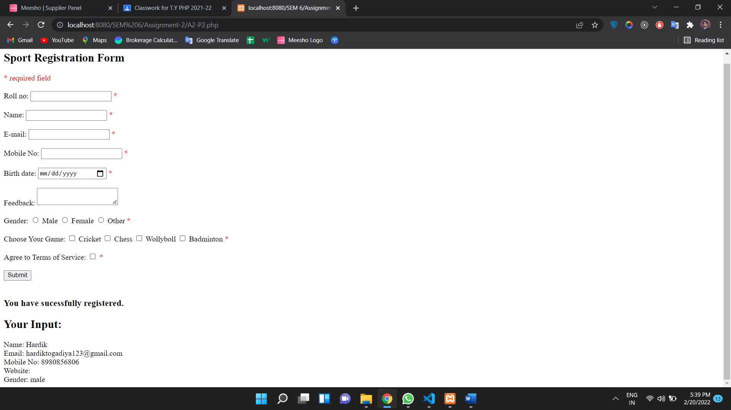

3. Write a program to check valid login id and password using html and JavaScript.

<html>

<body>

<script>

function validateform(){

var name=document.myform.name.value;

var password=document.myform.password.value;

if (name==null || name==""){

  alert("Name can't be blank");

  return false;

}else if(password.length<6){

  alert("Password must be at least 6 characters long.");

  return false;

  }

}

</script>

<body>

<form name="myform" method="post" action="http://www.javatpoint.com/javascriptpages/valid.jsp" onsubmit="return validateform()" >

Name: <input type="text" name="name"><br/>

Password: <input type="password" name="password"><br/>

<input type="submit" value="register">

</form>

</body>

</html>

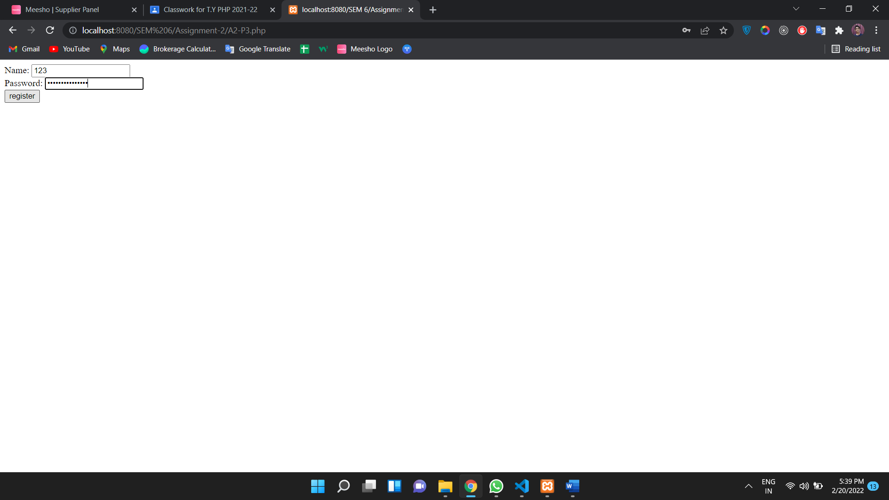

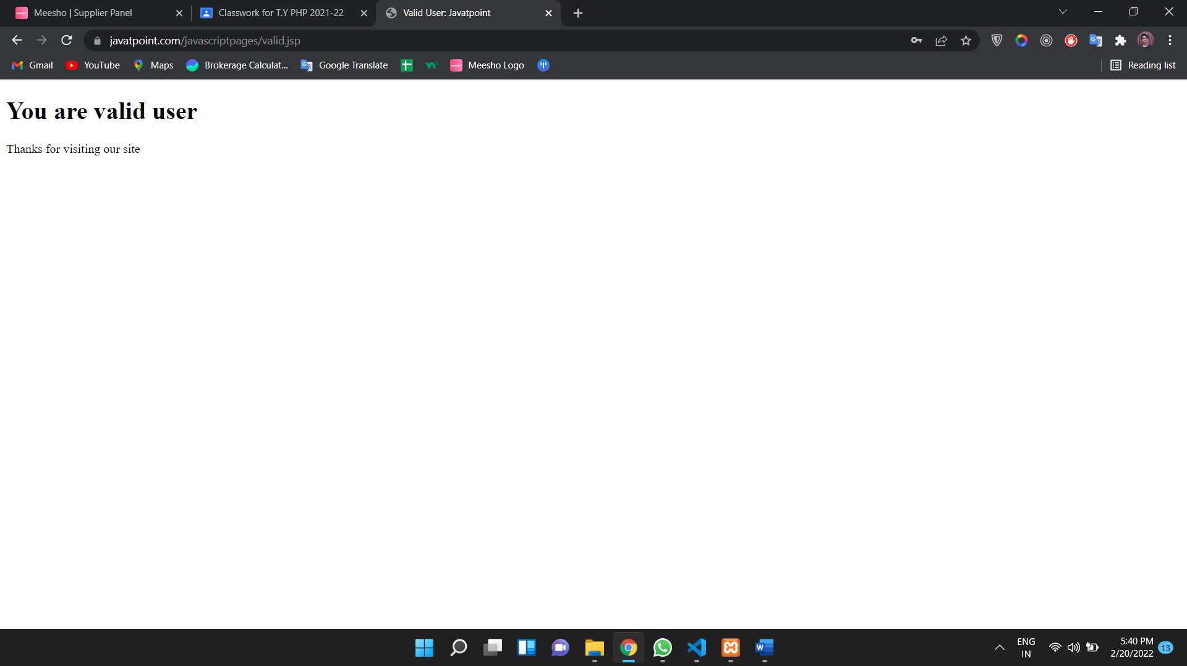

4. Write a PHP program to create calculator using user defined functions.

<!DOCTYPE html>

<head>

    <title>Simple Calculator Program in PHP - Tutorials Class</title>

</head>

<?php

$first_num = $_POST['first_num'];

$second_num = $_POST['second_num'];

$operator = $_POST['operator'];

$result = '';

if (is_numeric($first_num) && is_numeric($second_num)) {

    switch ($operator) {

        case "Add":

           $result = $first_num + $second_num;

            break;

        case "Subtract":

           $result = $first_num - $second_num;

            break;

        case "Multiply":

            $result = $first_num * $second_num;

            break;

        case "Divide":

            $result = $first_num / $second_num;

    }

}

?>

<body>

    <div id="page-wrap">

    <h1>PHP - Simple Calculator Program</h1>

      <form action="" method="post" id="quiz-form">

            <p>

                <input type="number" name="first_num" id="first_num" required="required" value="<?php echo $first_num; ?>" /> <b>First Number</b>

            </p>

            <p>

                <input type="number" name="second_num" id="second_num" required="required" value="<?php echo $second_num; ?>" /> <b>Second Number</b>

            </p>

            <p>

                <input readonly="readonly" name="result" value="<?php echo $result; ?>"> <b>Result</b>

            </p>

            <input type="submit" name="operator" value="Add" />

            <input type="submit" name="operator" value="Subtract" />

            <input type="submit" name="operator" value="Multiply" />

            <input type="submit" name="operator" value="Divide" />

      </form>

    </div>

</body>

</html>

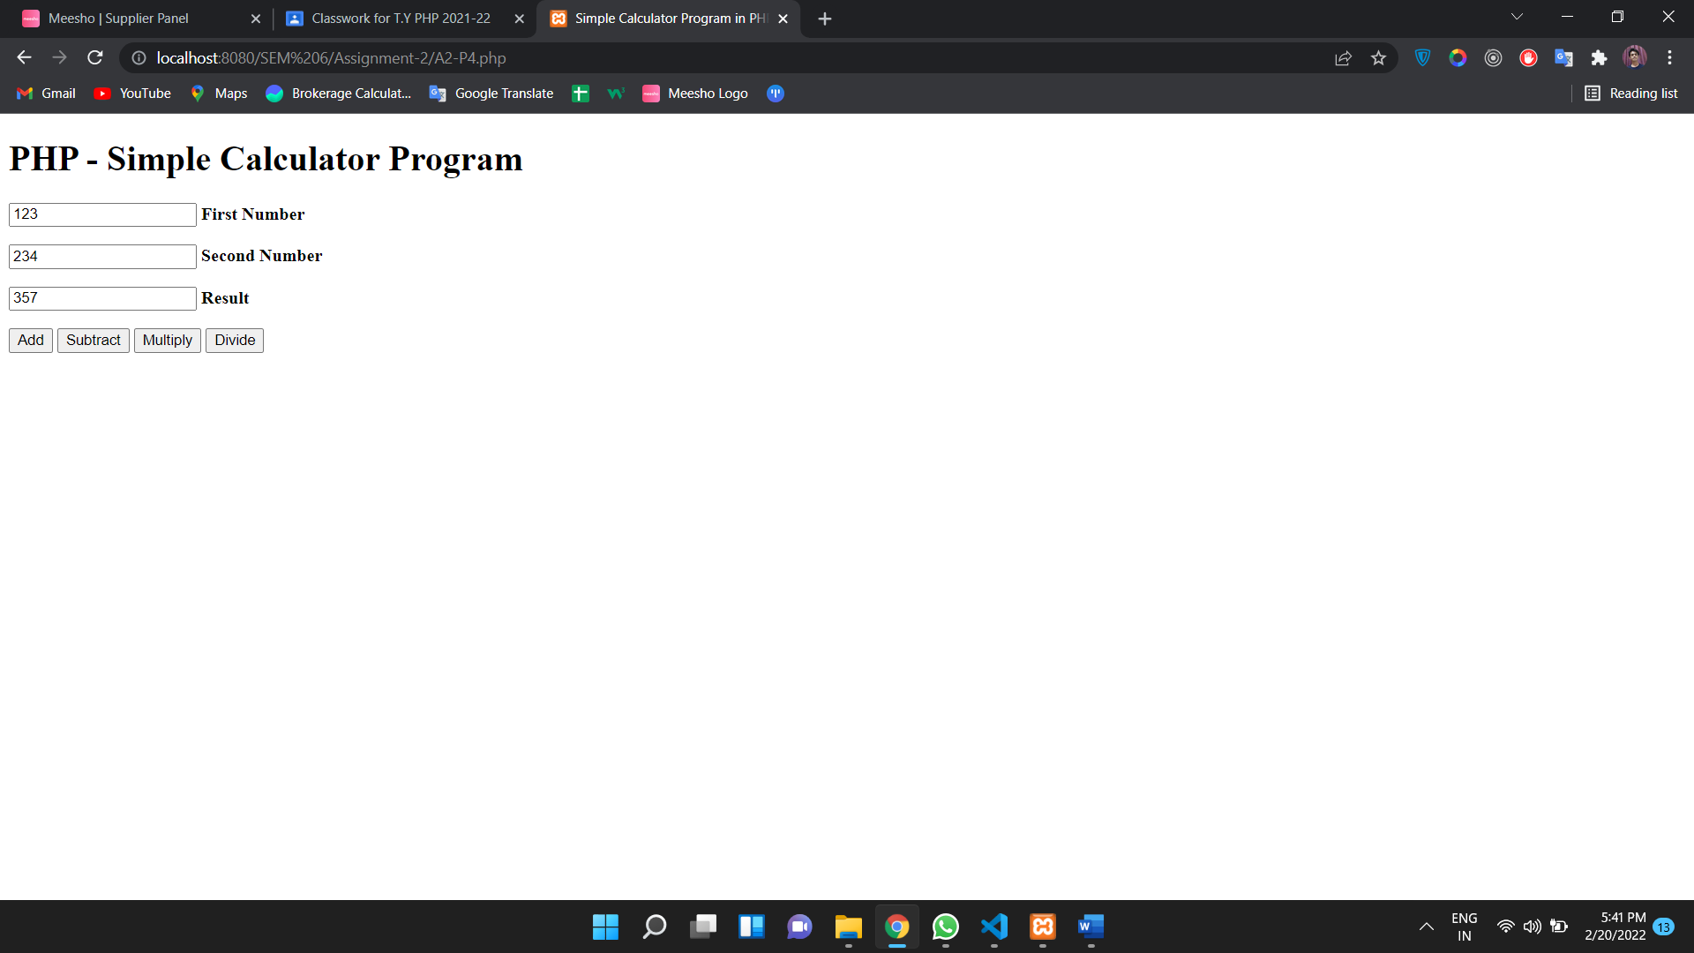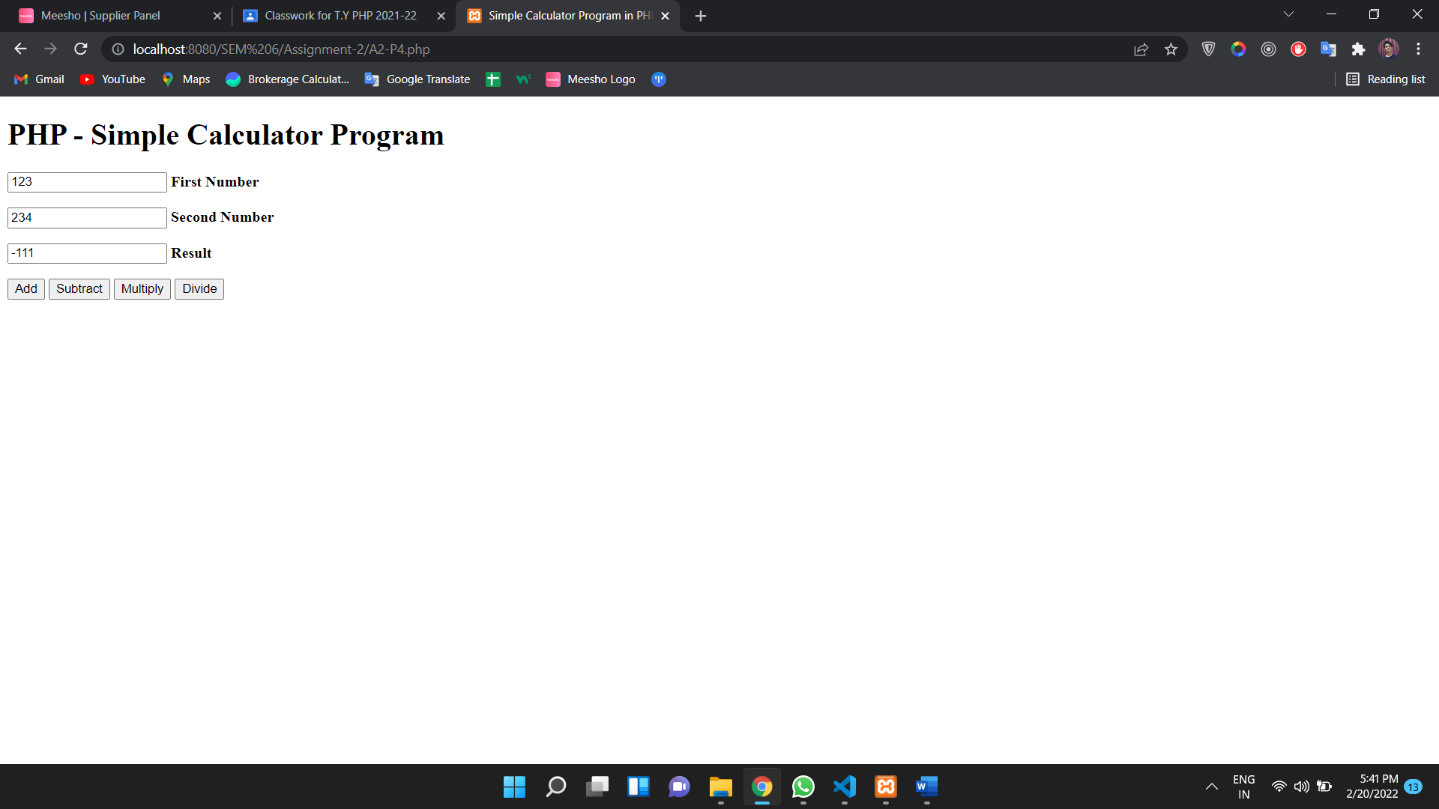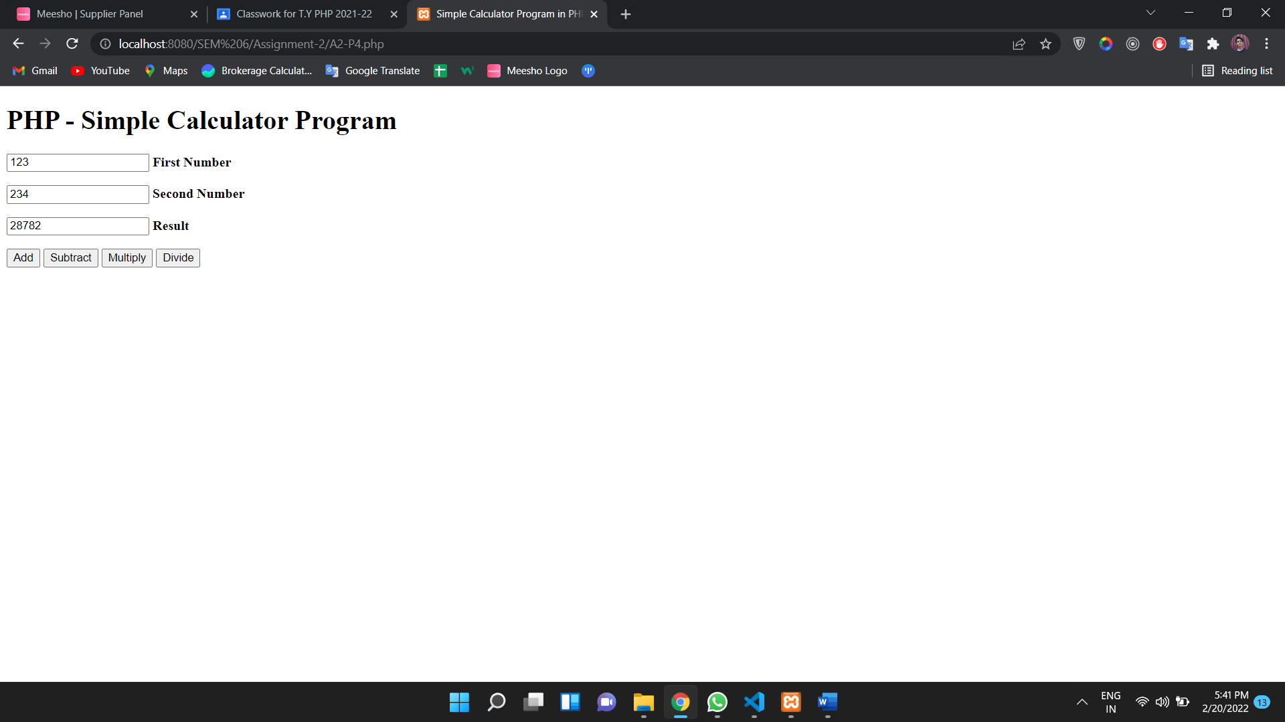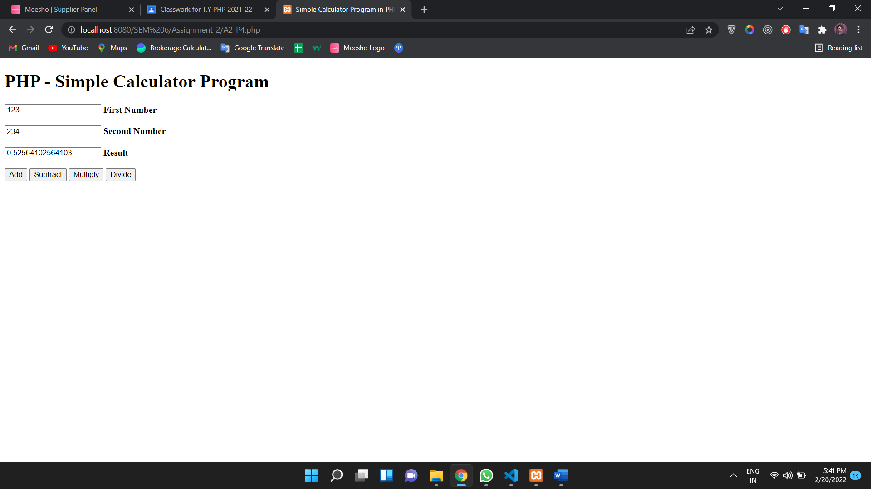

5. Write a PHP program which work on the global Keyword

<?php

$a = 1;

$b = 2;

function Sum()

{

    global $a, $b;

    $b = $a + $b;

}

Sum();

echo $b;

?>

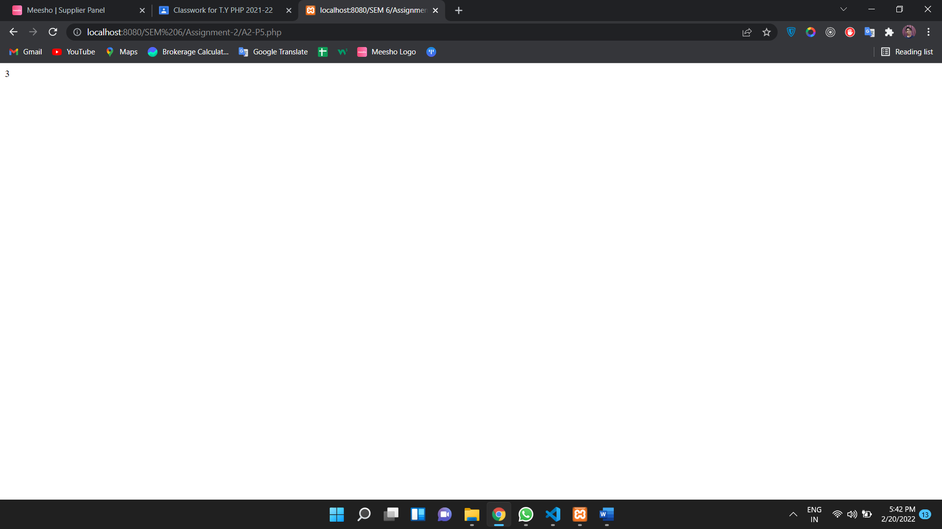

6. Write a PHP program using ‘get method’

<html>

   <body>

      <form action = "A2-P6-2.php" method = "GET">

         Username: <input type = "text" name = "username" /> <br>

         Blood Group: <input type = "text" name = "bloodgroup" /> <br>

         <input type = "submit" />

      </form>

   </body>

</html>



<html>

   <body>

      Welcome <?php echo $_GET["username"]; ?> </br>

      Your blood group is: <?php echo $_GET["bloodgroup"]; ?>

   </body>

</html>



7. Write a PHP program for print variable value into text box.

<html>

    <body>

        <form action="" method="post">

            Name:

            <input type=text name="t1">

            <br>

            <br>

            <input type=submit name="s">

            <?php

if(isset($_POST['s']))

{

    $a=$_POST['t1']; //accessing value from the text field

    echo "The name of the person is:-".$a; //displaying result

}

            ?>

        </form>

    </body>

</html>

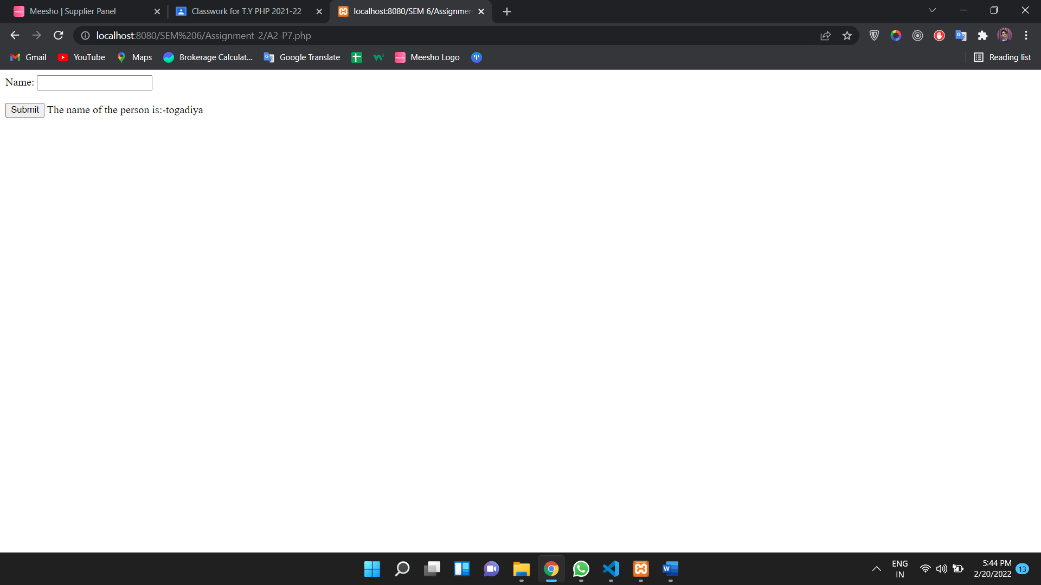

8. Write a PHP program for check given number is positive or negative or zero

<?php

function CheckNumber($x) {

  if ($x > 0)

    {$message = "Positive number";}

  if ($x == 0)

    {$message = "Zero";}

  if ($x < 0)

    {$message = "Negative number";}

  echo $message."\n";

}

CheckNumber(5.5);

CheckNumber(-10.8);

?>

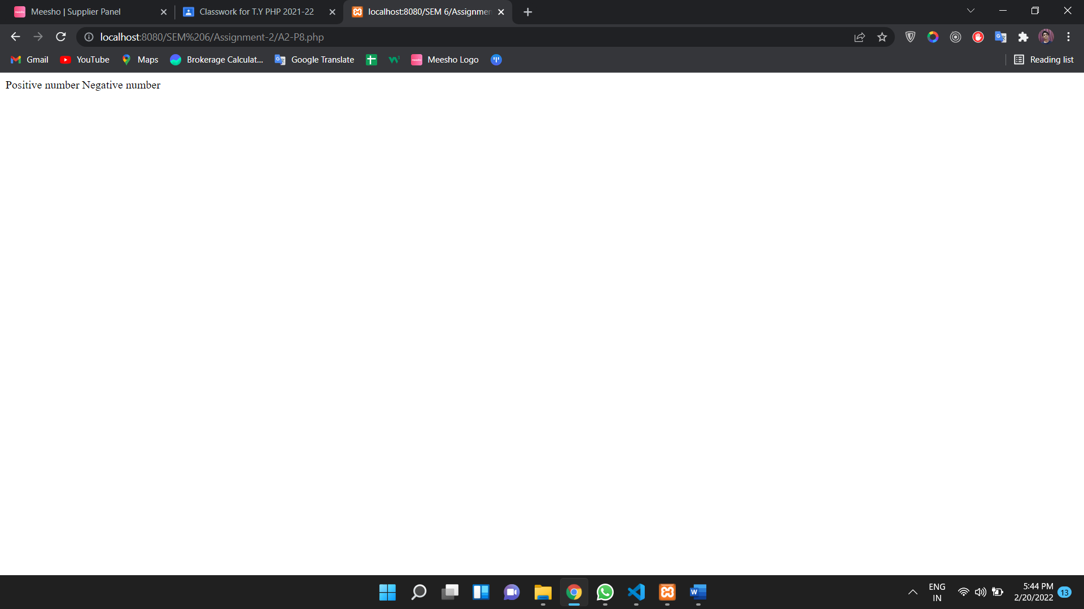

9. Write a PHP program which have usage of string built-in functions

<html>

<body>

<?php

//addcslashes

$str = addcslashes("Hello World!","W");

echo($str . "<br> <br>") ;

//join

$arr = array('hello','World!','Beautiful','Day!');

echo join(" ",$arr ) ;

//rtrim

$str1 = "hello  hunny!";

echo $str1 . "<br>";

echo rtrim($str1,"World!" );

//ltrim

$str = "Hello hunny!";

echo $str . "<br>";

echo ltrim($str,"Hello");

?>

</body>

</html>

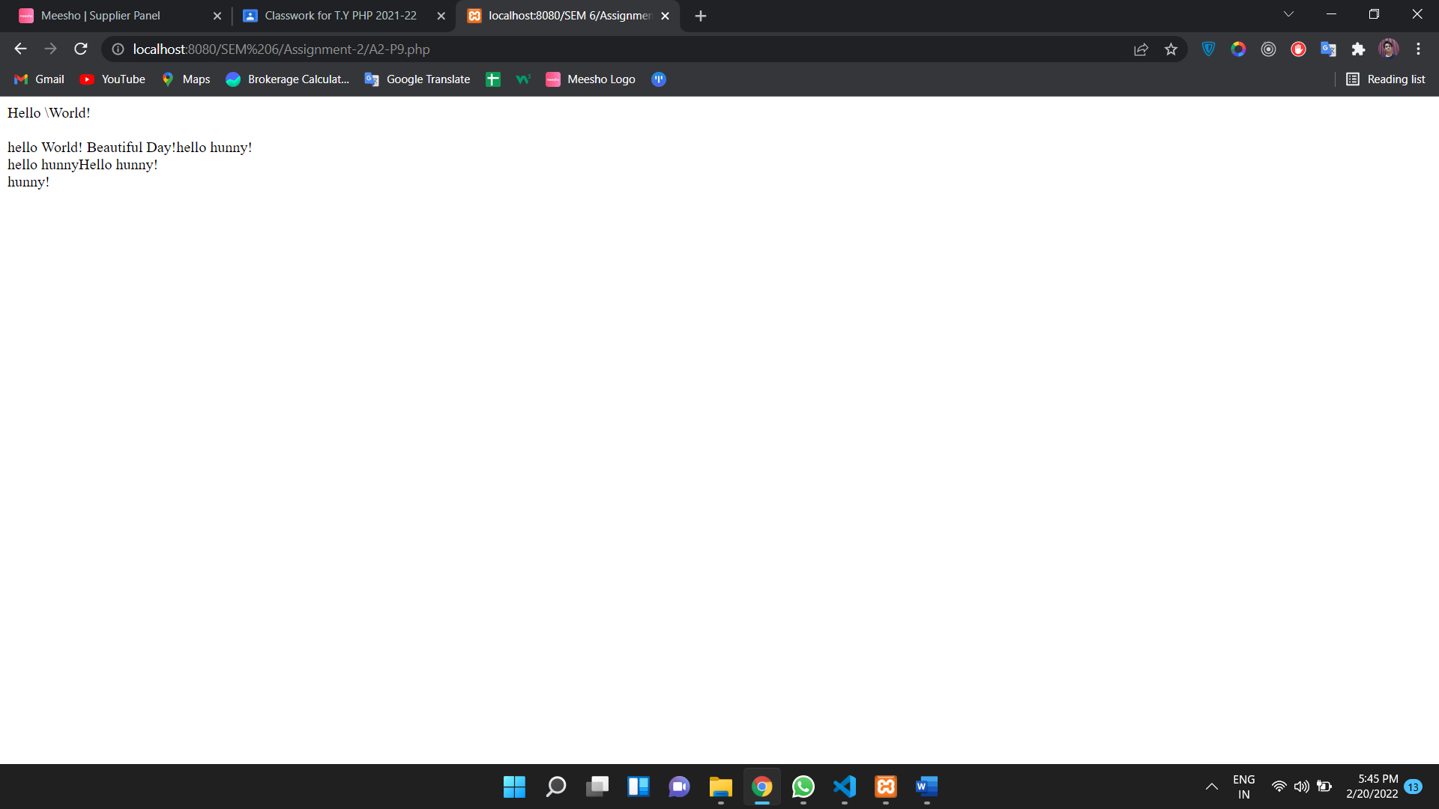

10. Write a PHP program which is execute while and do. while loop

<html>

<body>

 <form method="post">

 Enter the Number:

   <input type="number" name="number">

   <input type="submit" value="Submit">

  </form>

</body>

</html>

<?php

 if($_POST)

 {

  //get the number entered

  $number = $_POST['number'];

  //store entered number in a variable

  $a = $number;

  $sum  = 0;

  //run loop till the quotient is 0

  while( $a != 0 )

  {

   $rem   = $a % 10; //find reminder

   $sum   = $sum + ( $rem * $rem * $rem ); //cube the reminder and add it to the sum variable till the loop ends

   $a   = $a / 10; //find quotient. if 0 then loop again

  }

  //if the entered number and $sum value matches then it is an armstrong number

  if( $number == $sum )

  {

   echo "Yes $number an Armstrong Number";

  }else

  {

   echo "$number is not an Armstrong Number";

  }

 }

?>

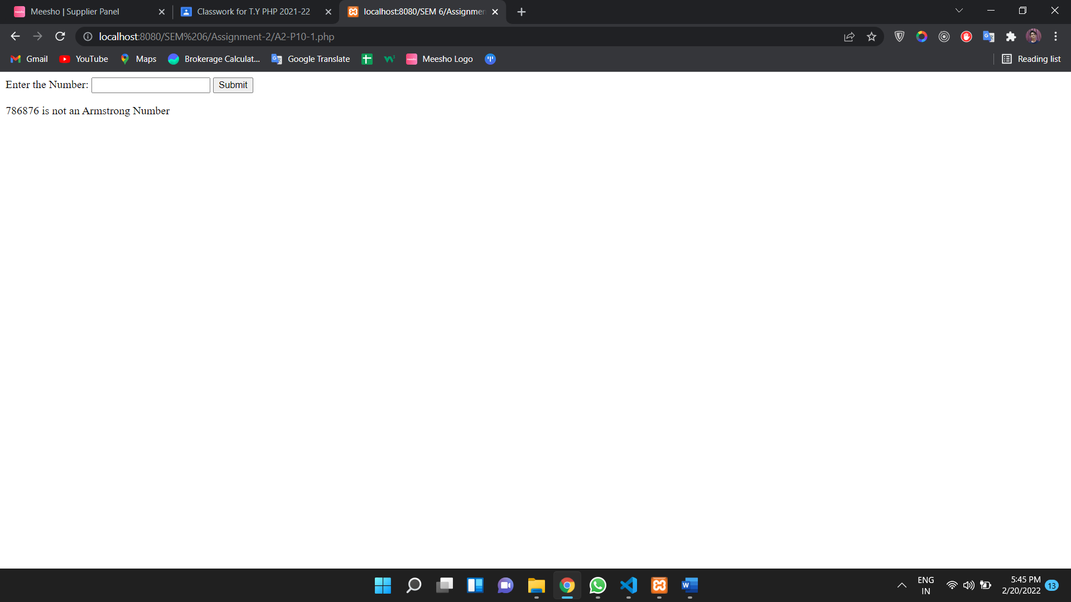

<!DOCTYPE html>

<html>

<body>

<?php

$x = 1;

$num = 123454321;

$x = 0;

$n =$num;

do {

 $mod = $num%10;

$x = $x * 10 + $mod;

$num = $num/10;

} while (floor($num));

if($n==$x)

{

echo "$n is a Palindrome number.";

}

else

{

echo "$n is not a Palindrome number.";

}

?>

</body>

</html>

